Task 1. Set up your environment
- Enable the Vertex AI API
Navigate to the Vertex AI section of your Cloud Console and click ENABLE ALL RECOMMENDED APIS.

Task 2. Create a Colab Enterprise Notebook
- In the Vertex AI section, scroll down to Notebooks. Click Colab Enterprise.
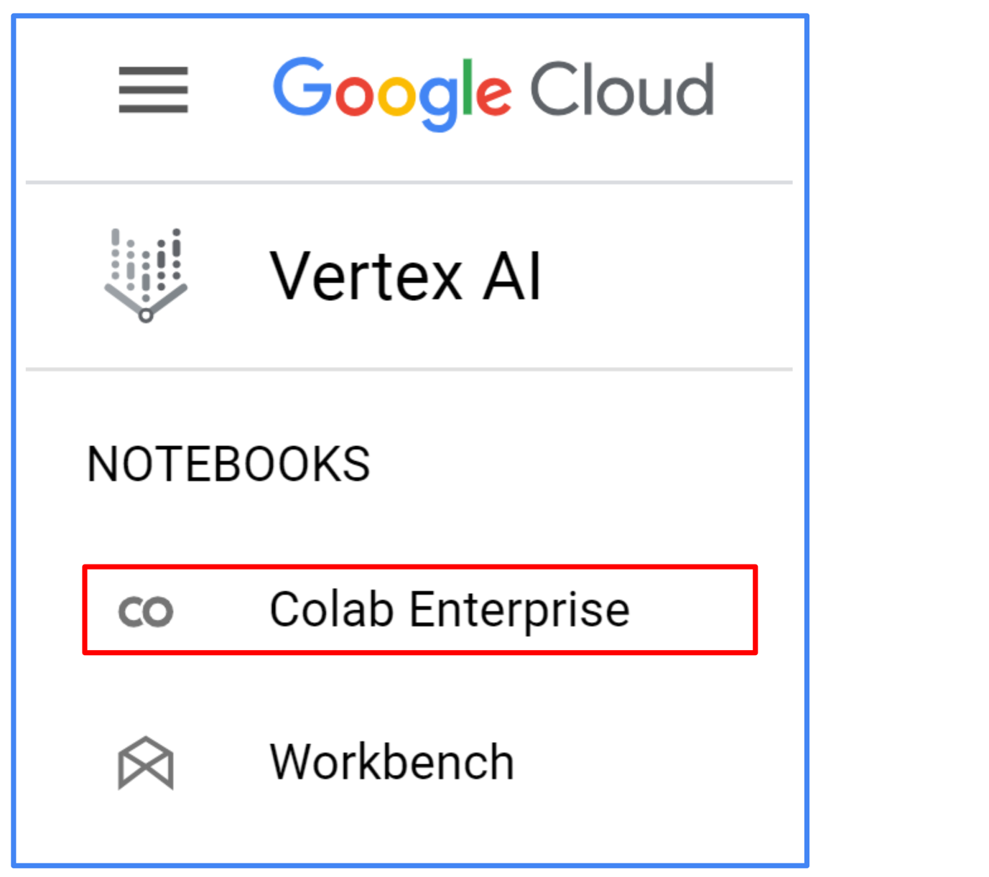
A "Welcome to Colab Enterprise" page then appears.
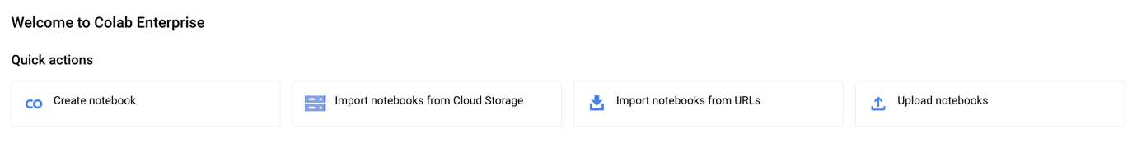
- In the Region menu, select the region us-central1, where you create the notebook.
- Click + CREATE NOTEBOOK in Quick actions section.
A new notebook will opened.
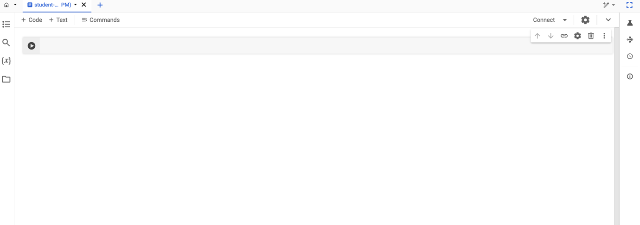
In order to execute the cells you need to create a runtime. Recall that runtimes are instances derived from runtime templates that allow users to run Colab notebooks. To create a runtime, you need to first create a runtime template.
- Click RUNTIME TEMPLATES. On the Runtime Templates page, click + NEW TEMPLATE.
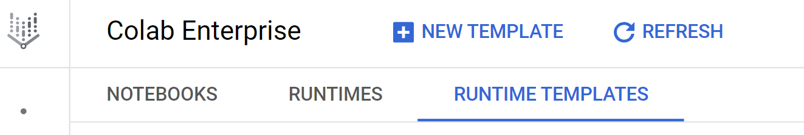

Runtime Basics
There are three steps. Step 2 and Step 3 are optional.
Step 1: Provide runtime basic information and select region as us-central1
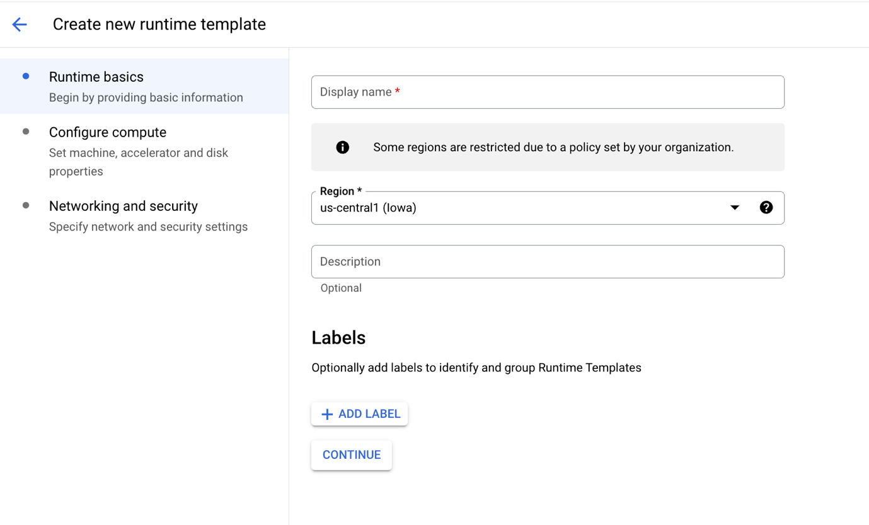

Compute Configure
Step 2: Configure Compute (Optional)
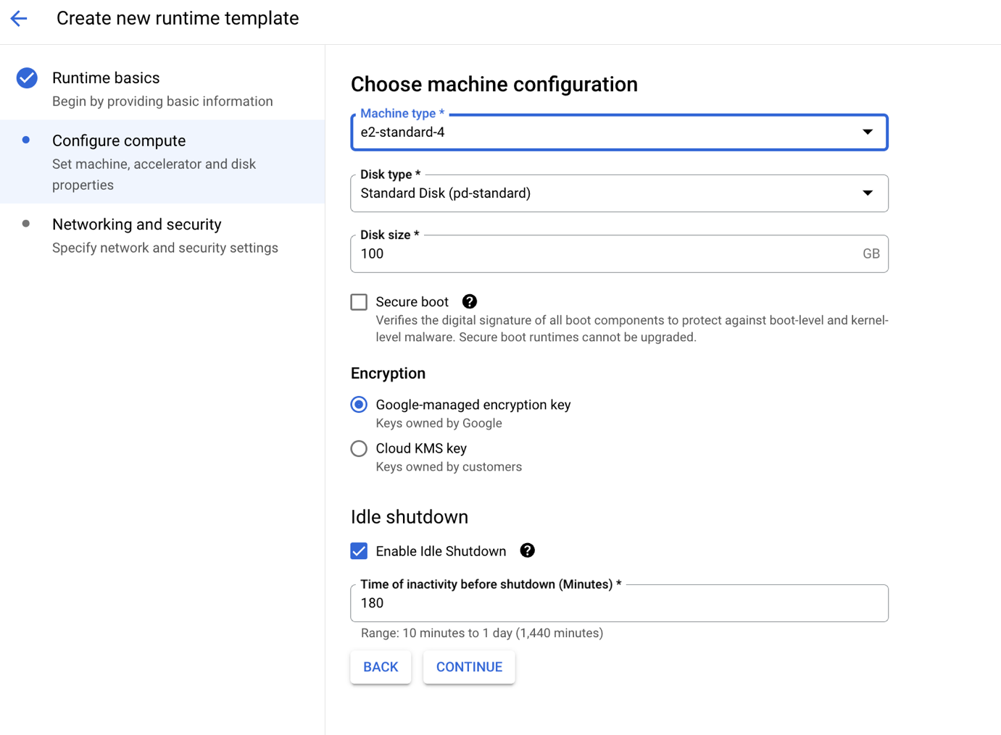

Networking and Security
Step 3: Networking and Security (Optional)
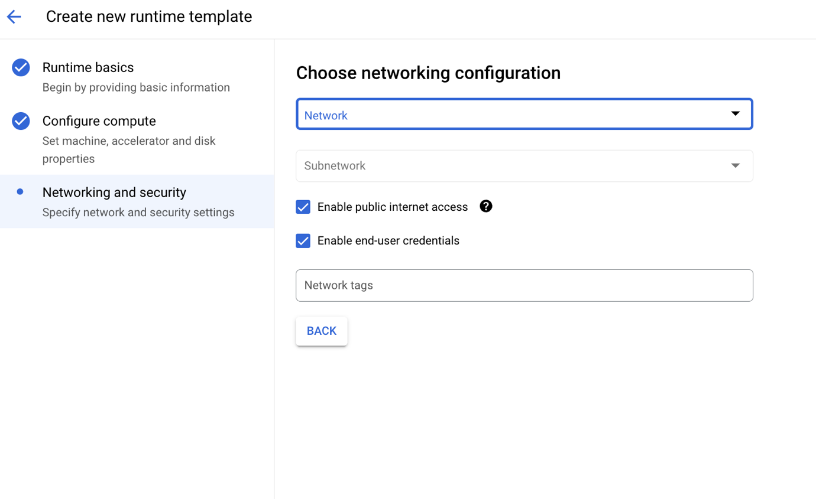
Click Create.

Task 3. Run Code in a Colab Enterprise Notebook
In this example, the code cell below “Getting Started” uses numpy to generate some random data and uses matplotlib to visualize it.
- Click Colab Enterprise then click on your created Notebook.
- Copy the code below and click Run icon to run the cell.
- import numpy as np
- from matplotlib import pyplot as plt

- ys = 200 + np.random.randn(100)
- x = [x for x in range(len(ys))]

- plt.plot(x, ys, '-')
- plt.fill_between(x, ys, 195, where=(ys > 195), facecolor='g', alpha=0.6)

- plt.title("Sample Visualization")
plt.show()
Copied!
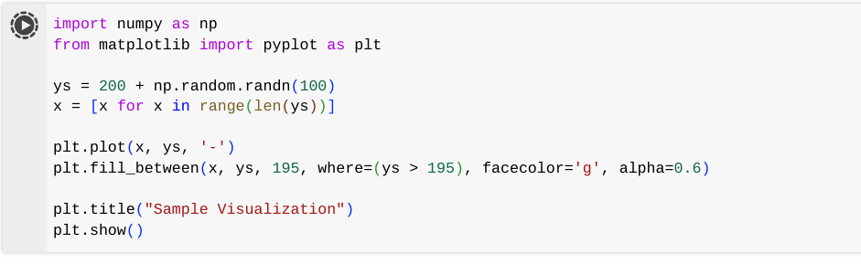
As you execute the cell, a massage pops up indicating that the runtime is active and initiating a connection - as shown in the image below.
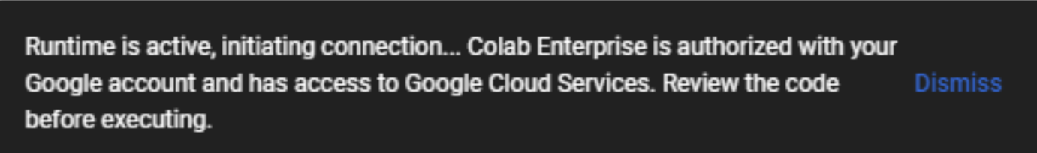
- Click Open for Open OAuth popup then select your User Name then click Allow.
- Now check the cell you executed, there should be a green check mark next to, this indicates that the cell executed properly.
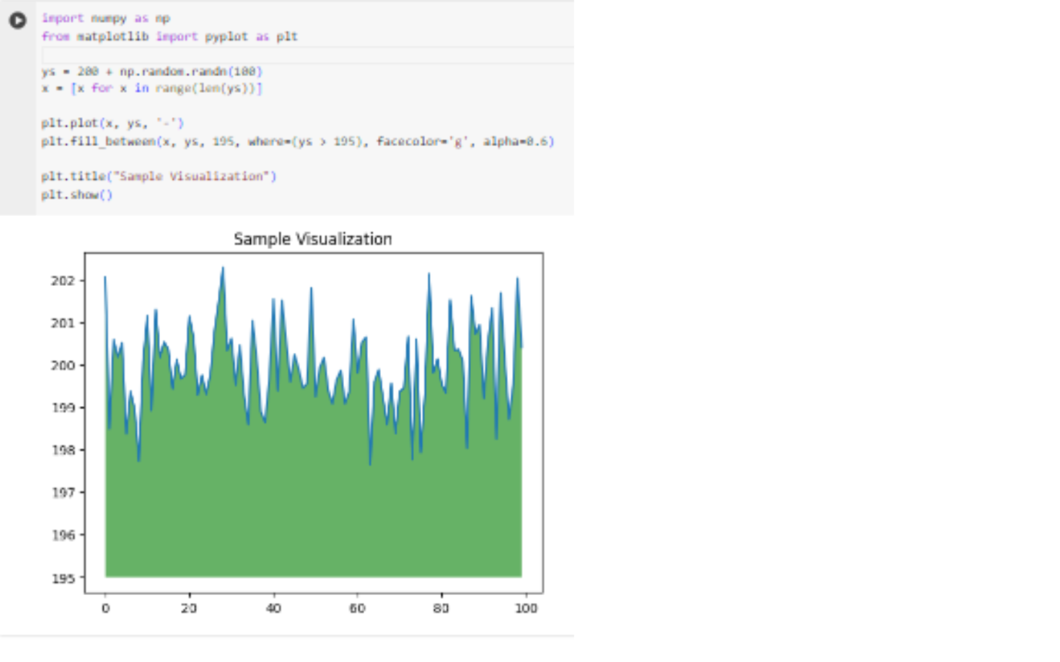
- Now, make a change to the code - for example, change the title of the plot from "Sample Visualization" to "Colab Enterprise". Then, execute the cell.
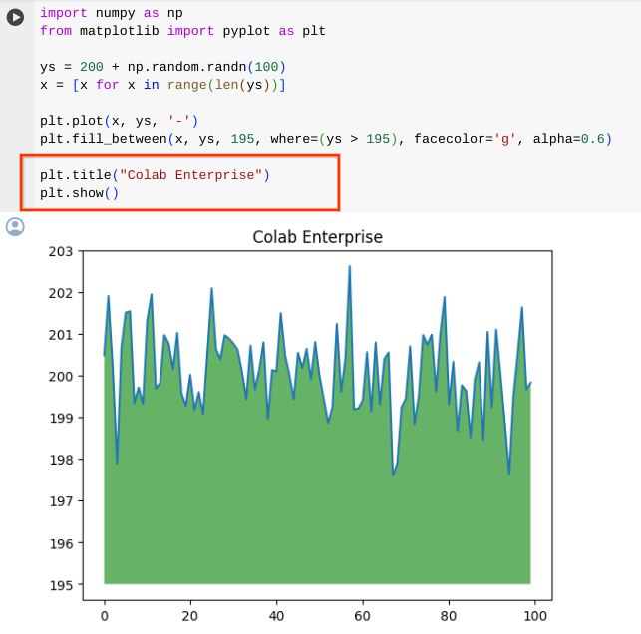

Task 4. Show revision history
One of the most important features of software development is the ability to track version history.
- Go to the Notebook Storage section. Click on the three dots beside the notebook you created.
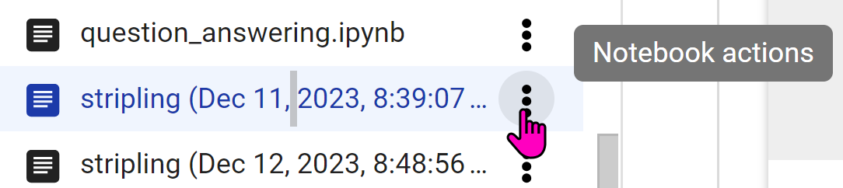
- Select Revision History (as shown in bubble #1 in the image below).
When revision history is selected, you see the changes side by side with a date stamp and color-coding to see the “old” in red and the “new” in green (as shown in bubble #2). There are three options to view revision history: the raw source, the inline differences, or the source output (as shown in bubble #3).
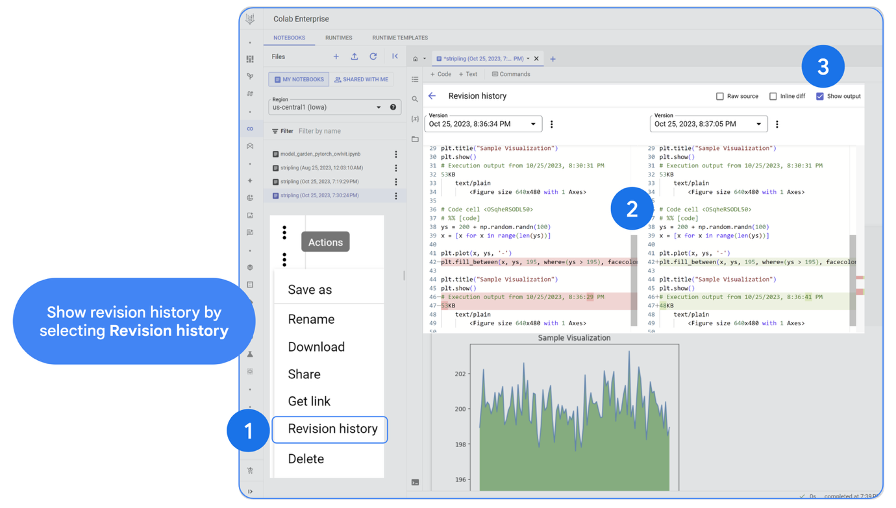

Task 5. Add code to cells
To add code or text to a Notebook, simply click on either code or text in the menu bar above the Notebook Editor.
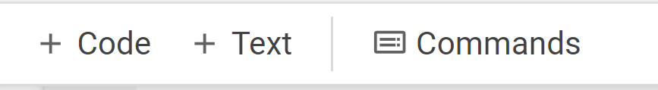
Now, you will add several blocks of code to the notebook. After you copy a block of code, run the code to see the output. Note - Some cells will have not output (such as when you import the libraries). When you are done, share the notebook.
- Go back to the Notebook storage section then click on your Notebook.
- Re-run the first code again.
- Add a code cell.
- Copy the code below into the new cell.

Import libraries
import seaborn as sns
import pandas as pd
import numpy as np
from google.cloud import bigquery
bq = bigquery.Client()
Copied!
- Click the Run icon to run the cell.
There should be no output shown.
Insert the following code as cells to import the necessary modules and initialize a BigQuery client. The BigQuery client will be used to send and receive messages from the BigQuery API.

Import BigQuery Client
client = bigquery.Client()

query = """SELECT * FROM `bigquery-public-data.catalonian_mobile_coverage_eu.mobile_data_2015_2017` LIMIT 1000"""
job = client.query(query)
df = job.to_dataframe()
Copied!
No output shown.

Download a BigQuery Table into a Pandas Dataframe
In Google, %%bigquery is a magic command used within Jupyter notebooks and other interactive environments to interact with BigQuery. Therefore, %%bigquery essentially tells your environment to wwitch to BigQuery mode: It prepares the environment to accept and execute BigQuery queries. BigQuery will execute the query, retrieve the data, and present it to you within the notebook environment, often as a pandas DataFrame (e.g. the "df" as shown in the code)
%%bigquery df
SELECT *
FROM `bigquery-public-data.catalonian_mobile_coverage_eu.mobile_data_2015_2017`
Copied!
Output shown: 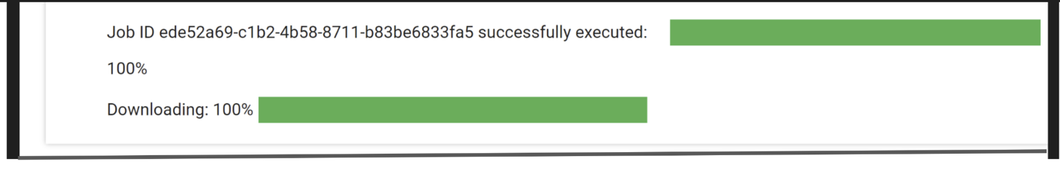

Show the first five rows of the Pandas Dataframe
df.head()
Copied!
Output shown: 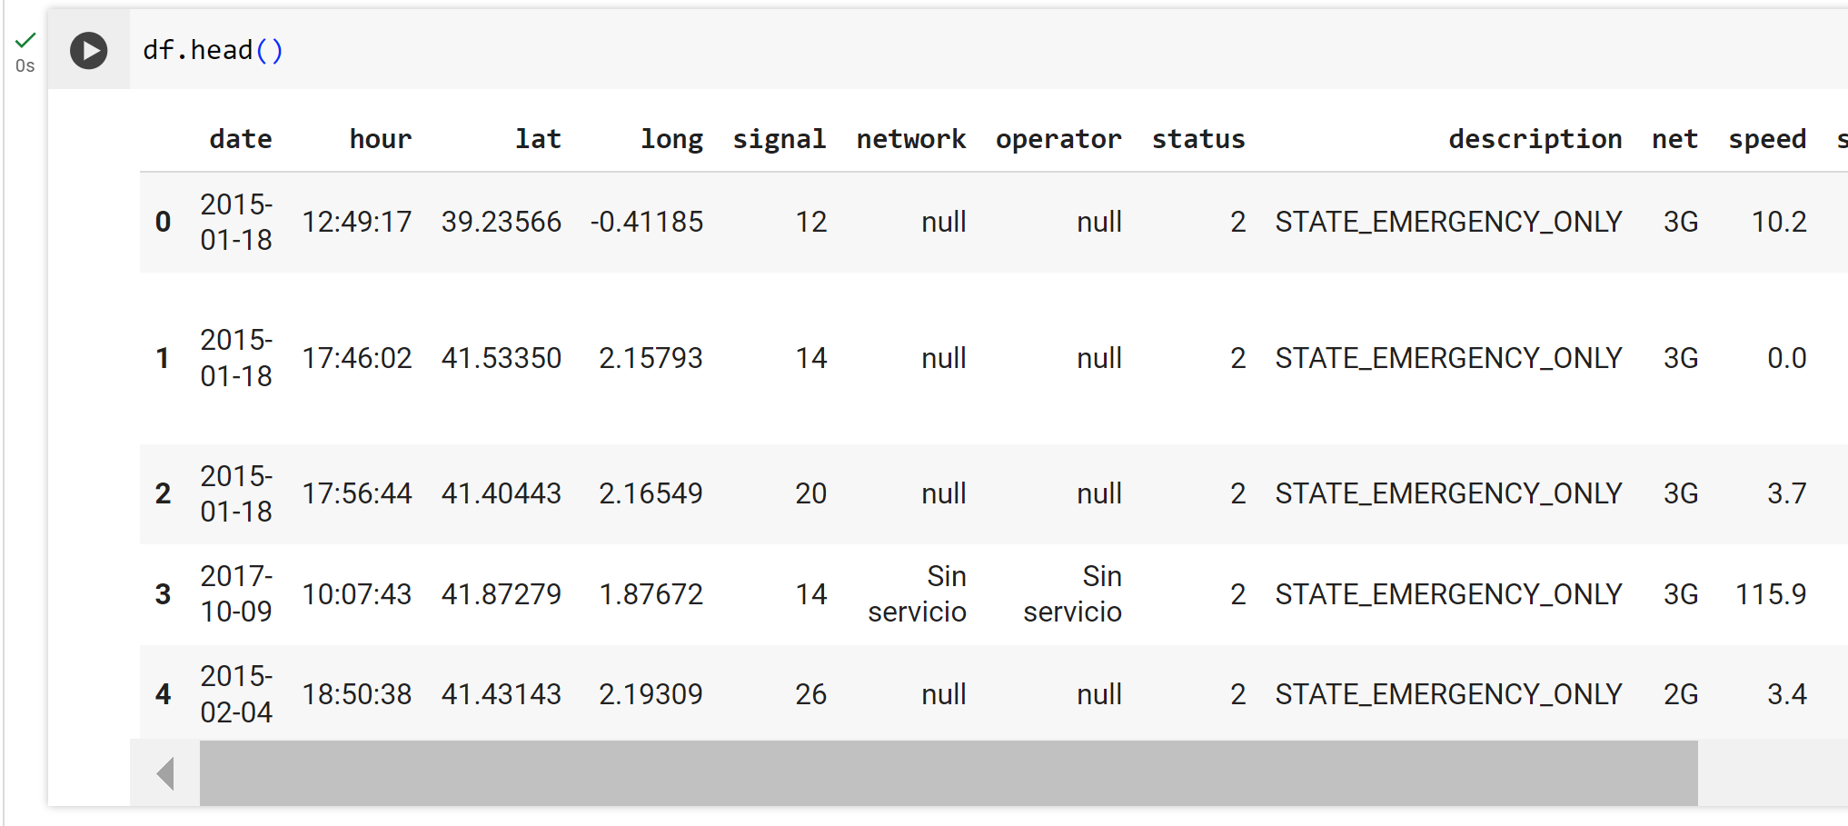

Get information on the Pandas Dataframe
df.info()
Copied!
Output shown: 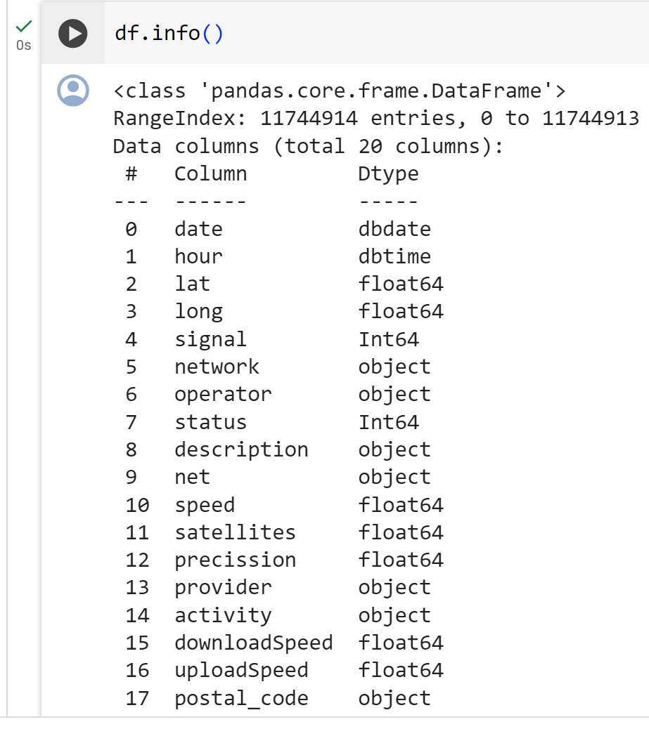

Get statistics on the Pandas Dataframe
df.describe()
Copied!
Output shown: 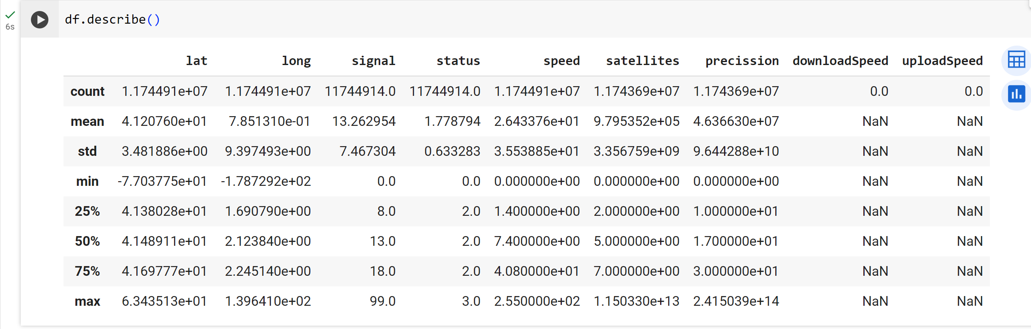

Plot a correlation using Seaborn.
numeric_df = df.select_dtypes(include=[np.number])

corr_matrix = numeric_df.corr()

plt.figure(figsize=(10, 5))
sns.heatmap(corr_matrix, annot=True, vmin=0, vmax=1, cmap='viridis')
plt.show()
Copied!
Output shown: 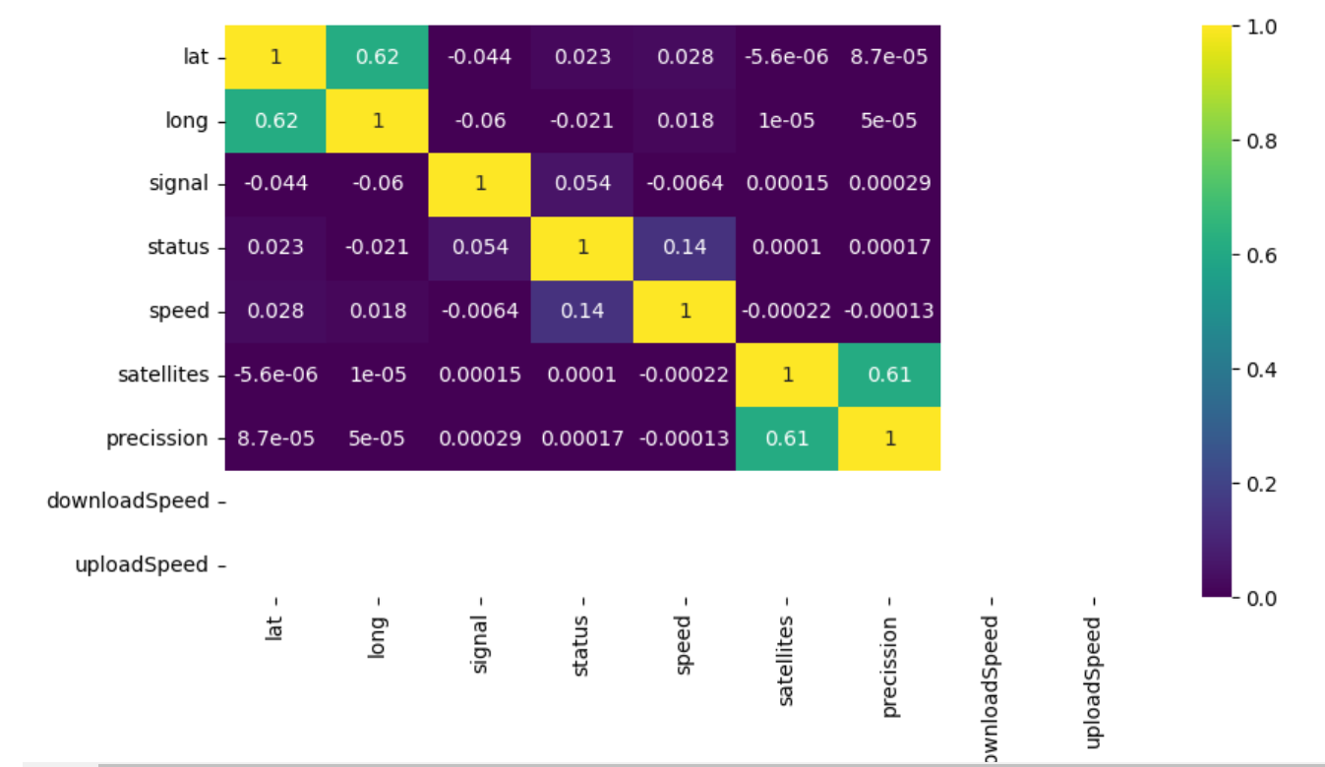

Write a SQL query to pick up specific fields from a BigQuery dataset
%%bigquery df2
SELECT signal, status
FROM `bigquery-public-data.catalonian_mobile_coverage_eu.mobile_data_2015_2017`
Copied!
Output shown: 

Get the first five rows of the new fields.
df2.head()
Copied!
Output shown: 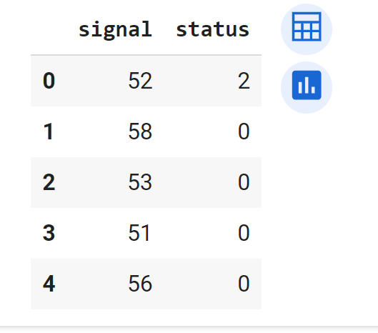

Task 6. Share the Notebook
Next, share your notebook.
- When you select “Share” by right-clicking on the notebook, a share permissions window appears, which allows you to edit or delete permissions, or select "Add Principal" to grant new access.
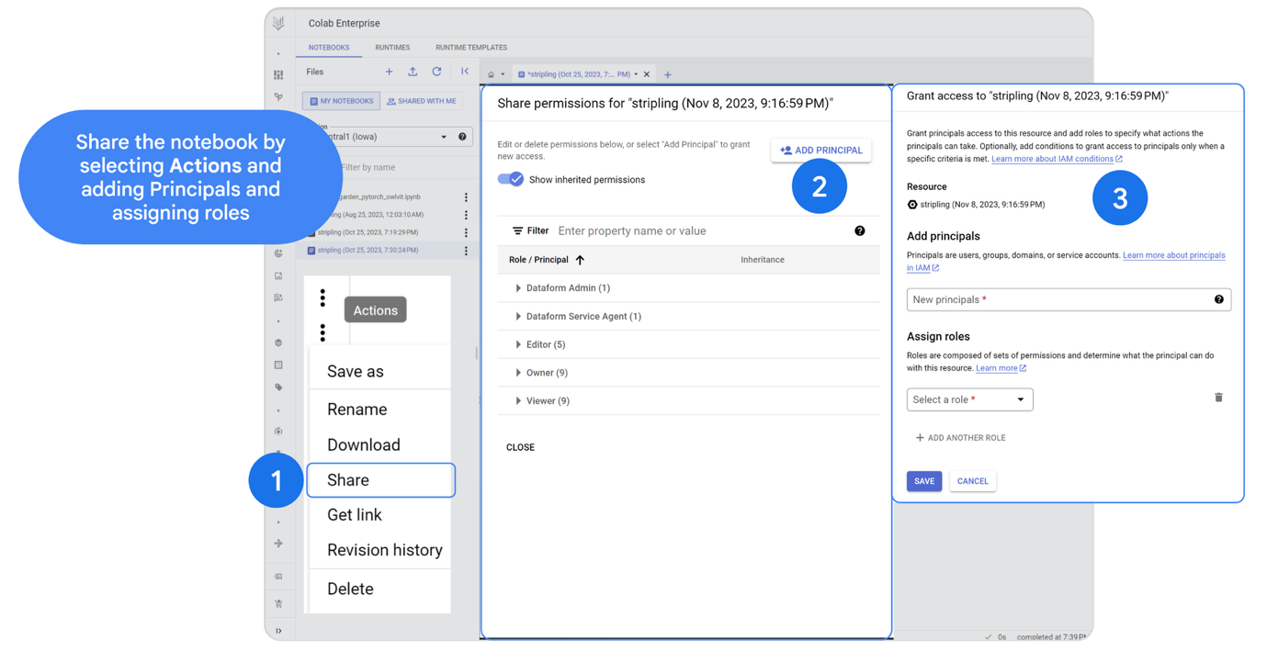
- When you grant principals access to a resource, you also add roles to specify what actions the principals can take. Optionally, you can add conditions to grant access to principals only when a specific criteria is met.
Principals are users, groups, domains, or service accounts Roles are composed of sets of permissions and determine what the principal can do with this resource.

Congratulations!
In this lab you learned how to:
- Create a Colab Enterprise Notebook
- Connect to BigQuery datasets
- Perform statistical analyis on a Pandas Dataframe
- Create Seaborn plots for Exploratory Data Analysis in Python
- Write a SQL query to pick up specific fields from a BigQuery dataset
- Use version history to see code changes
- Share a Colab Enterprise notebook

End your lab
When you have completed your lab, click End Lab. Google Skills removes the resources you’ve used and cleans the account for you.
You will be given an opportunity to rate the lab experience. Select the applicable number of stars, type a comment, and then click Submit.
The number of stars indicates the following:
- 1 star = Very dissatisfied
- 2 stars = Dissatisfied
- 3 stars = Neutral
- 4 stars = Satisfied
- 5 stars = Very satisfied
You can close the dialog box if you don't want to provide feedback.
For feedback, suggestions, or corrections, please use the Support tab.
Manual Last Updated December 11, 2024
Lab Last Tested December 11, 2024
Copyright 2024 Google LLC All rights reserved. Google and the Google logo are trademarks of Google LLC. All other company and product names may be trademarks of the respective companies with which they are associated.

